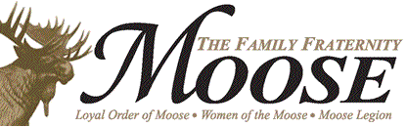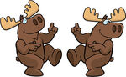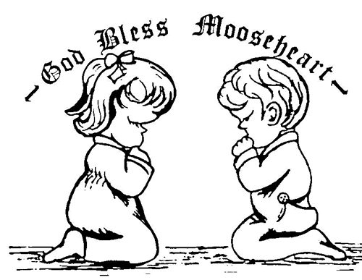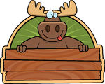

**Snacks**

1.00 . .75 . .75

Candy Bar ……….

Chips ………….…

Peanuts ………….

**Salads**

Chef Salad ………….….

Side Salad ……………..

Grilled Chicken Salad*…

5.75

2.50

5.75

**Drinks**

Coffee …………...

Tea ……………….

(Sweet or Unsweet)

Fountain Drink …..

Can Soft Drink …..

Bottle Water ……...

.75

.75

.75

1.00

1.00

Ham Sandwich….…..…..

++Philly Cheese Steak ….

Philly Chicken Steak ……

Pork BBQ ………….….....

Tuna Salad …………...….

Turkey Sandwich ….....…

++Reuben ………………..

++ Limited availability++

3.75

4.75

4.75

4.50

3.50

3.75

4.75

**Tuckahoe Moose Lodge Menu**

***Welcome to the Moose!***

2.50

2.75

3.00

2.00

1.25

3.00

Hamburger*……...……

Cheeseburger*……….

Chicken Tenders (2) …

Grilled Cheese ……….

Hot Dog ……………….

Mini Corndogs ………..

Served with Fries or Chips

**12 and Under**

**Junior Moose Menu**

All are served with chips. French Fries are 1.75 extra.

**Burgers \***

Bacon Cheeseburger*..

Bologna Burger*.………

Cheeseburger*…………

Hamburger*.…………….

4.00

3.25

3.75

3.50

All are served with chips. French Fries are 1.75 extra.

3.50

3.50

3.50

3.50

5.75

3.50

2.25

**Sandwiches**

BLT ………………...

Chicken, fried*….…

Chicken, grilled*......

Chicken Salad….…

Club ……………….

Fish* ………….……

Grilled Cheese .…..

4.50

1.75

1.75

2.25

2.75

5.75

Cheese Sticks (6) ….

Egg Roll (1) …………

French Fries (Sm) ….

French Fries (Lg) …..

Onion Rings (8) ….....

Wing Dings (8) ……..

**Appetizers**

**Plates and Baskets**

BBQ Plate.…………………....

BBQ, Slaw and Fries

Chicken Strips(3) and Fries…

Hot Dog and chips ……………

Chili .50 extra

Shrimp (7) and Fries..……….

6.00

5.50

1.25

6.00

**\*Consuming raw or undercooked meats, poultry, seafood, shellfish or raw eggs may increase your risk of food borne illness; especially if you have certain medical conditions. This warning also pertains to any lunch/dinner specials that contain meats, poultry, seafood, shellfish or eggs.**